Madagascar

## GNI per capita and development level

The data set shows the GNI per capita and development level of the country each year.

## # A tibble: 19 x 5  
## country iso3c date GNIperCapita devCategory  
## <chr> <chr> <dbl> <dbl> <chr>   
## 1 Madagascar MDG 1996 457. Low Income   
## 2 Madagascar MDG 1998 465. Low Income   
## 3 Madagascar MDG 2000 480. Low Income   
## 4 Madagascar MDG 2002 420. Low Income   
## 5 Madagascar MDG 2003 448. Low Income   
## 6 Madagascar MDG 2004 459. Low Income   
## 7 Madagascar MDG 2005 464. Low Income   
## 8 Madagascar MDG 2006 474. Low Income   
## 9 Madagascar MDG 2007 494. Low Income   
## 10 Madagascar MDG 2008 513. Low Income   
## 11 Madagascar MDG 2009 477. Low Income   
## 12 Madagascar MDG 2010 465. Low Income   
## 13 Madagascar MDG 2011 460. Low Income   
## 14 Madagascar MDG 2012 454. Low Income   
## 15 Madagascar MDG 2013 451. Low Income   
## 16 Madagascar MDG 2014 457. Low Income   
## 17 Madagascar MDG 2015 454. Low Income   
## 18 Madagascar MDG 2016 457. Low Income   
## 19 Madagascar MDG 2017 468. Low Income

## GDP growth and economic growth classification

The data set shows the GDP growth and the ecomic growth classification of the country each year.

## # A tibble: 19 x 5  
## country iso3c date GDPannualGrowthRate GDPgrowthCategory4  
## <chr> <chr> <dbl> <dbl> <fct>   
## 1 Madagascar MDG 1996 2.15 slow growth   
## 2 Madagascar MDG 1998 3.92 moderate growth   
## 3 Madagascar MDG 2000 4.46 moderate growth   
## 4 Madagascar MDG 2002 -12.4 negative grwoth   
## 5 Madagascar MDG 2003 9.78 fast growth   
## 6 Madagascar MDG 2004 5.26 moderate growth   
## 7 Madagascar MDG 2005 4.76 moderate growth   
## 8 Madagascar MDG 2006 5.40 moderate growth   
## 9 Madagascar MDG 2007 5.71 fast growth   
## 10 Madagascar MDG 2008 6.71 fast growth   
## 11 Madagascar MDG 2009 -3.98 negative grwoth   
## 12 Madagascar MDG 2010 0.619 slow growth   
## 13 Madagascar MDG 2011 1.58 slow growth   
## 14 Madagascar MDG 2012 3.01 moderate growth   
## 15 Madagascar MDG 2013 2.30 slow growth   
## 16 Madagascar MDG 2014 3.34 moderate growth   
## 17 Madagascar MDG 2015 3.13 moderate growth   
## 18 Madagascar MDG 2016 3.99 moderate growth   
## 19 Madagascar MDG 2017 3.93 moderate growth

## Development trend

The plot shows the development trend of the country.

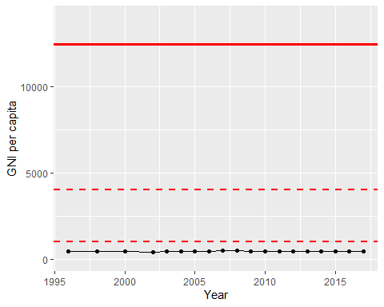

GNI Per Capita Trend